# MACHINE LEARNING

**LAB WORK 7**

**NAME: CHETHAN Y**

**USN: 22BTRAD011**

**Implementing Numpy**

**Code:**

#Implementing Numpy

import numpy as np

# Creating a NumPy array from a Python list

arr = np.array([1, 2, 3, 4, 5])

print(arr)

**Output:**

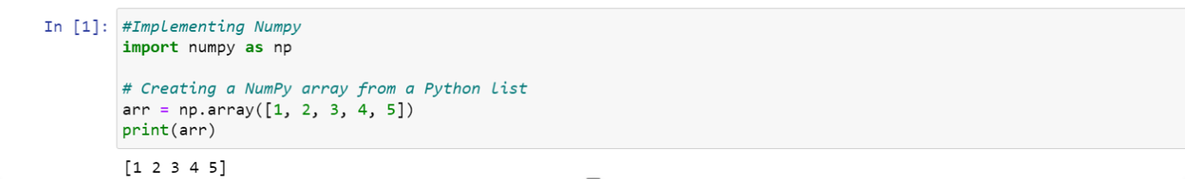

**Code:**

# Element-wise operations

arr1 = np.array([1, 2, 3])

print(arr1)

arr2 = np.array([4, 5, 6])

sum_result = arr1 + arr2

print(sum_result)

# Mathematical functions

sin_values = np.sin(arr1)

print(sin_values)

# Linear algebra operations

matrix1 = np.array([[1, 2], [3, 4]])

matrix2 = np.array([[5, 6], [7, 8]])

dot_product = np.dot(matrix1, matrix2)

print(dot_product)

**Output:**

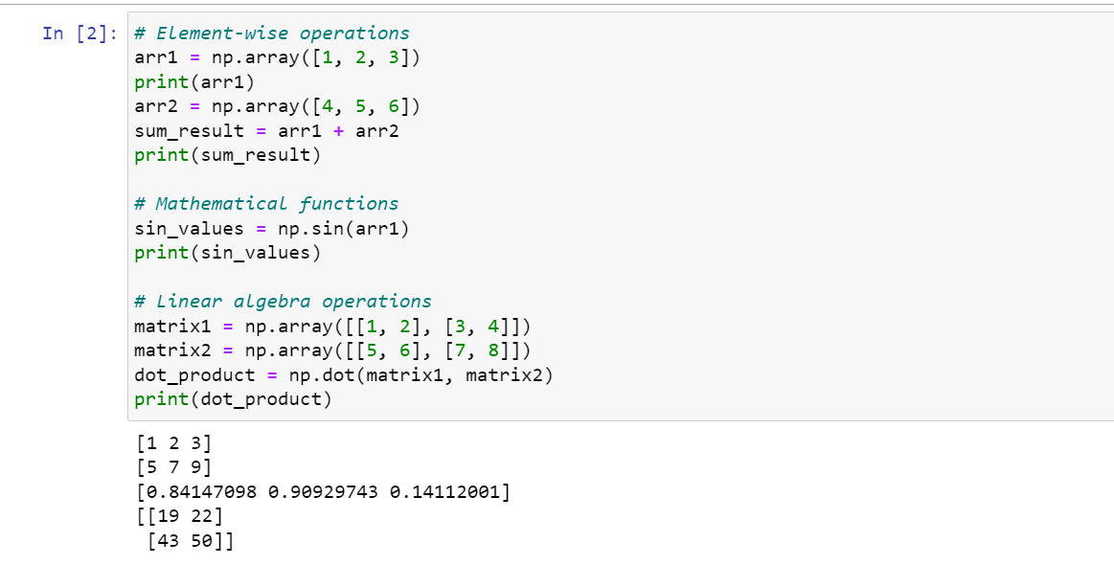

**Code:**

# Indexing

print(arr[0]) # Accessing the first element

# Slicing

print(arr[1:4]) # Accessing elements from index 1 to 3

**Output:**

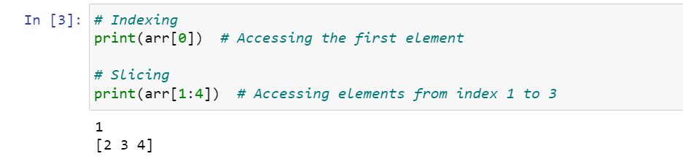

**Code:**

# Shape of an array

print(arr.shape)

# Reshaping

reshaped_arr = arr.reshape(5, 1)

print(reshaped_arr)

**Output:**

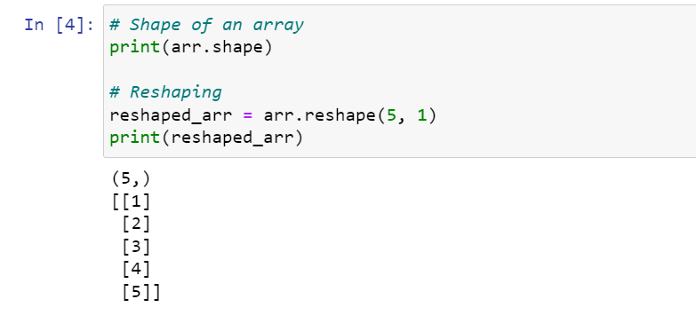

**GitHub Link: https://github.com/chethan1n1/machine-learning**